============================================================
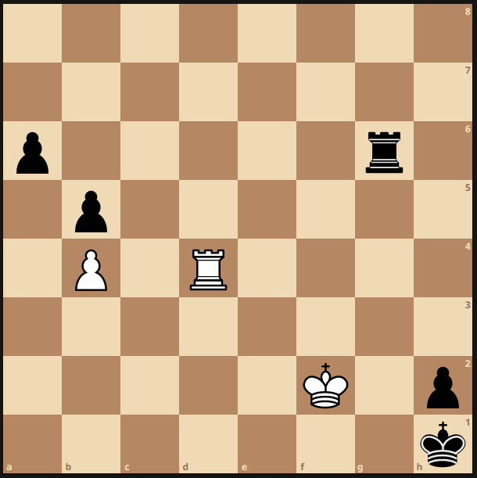
1.

1. White to play and win

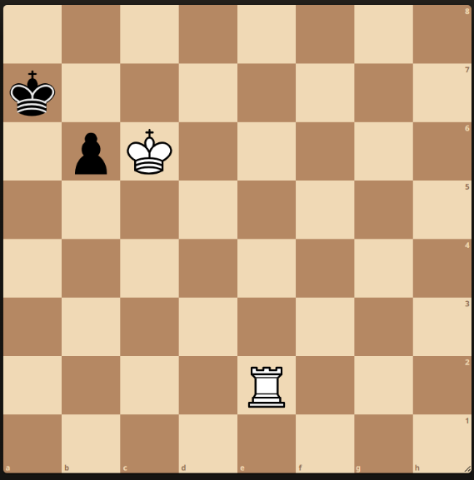
2.

2. White to play and mate in 3 moves

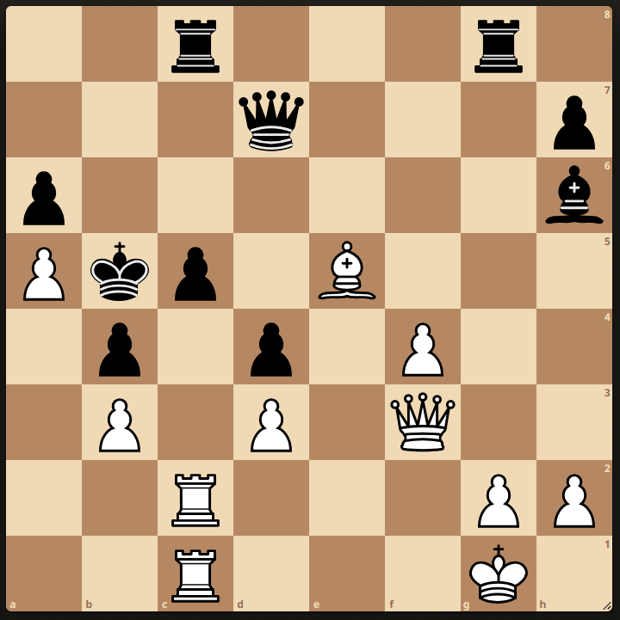
3.

3. White to play and win

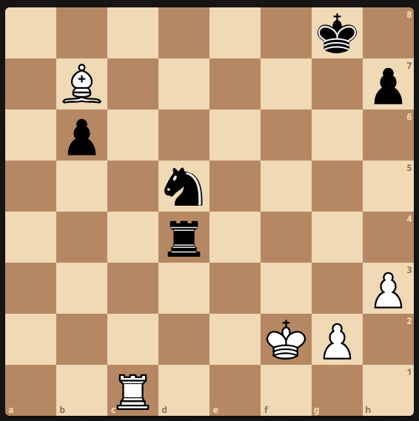
4.

4. White to play – Best move

U12 Section Solutions

1. Stamma 1737.
1. Rd1+ Rg1 2. Rf1

2. Lehner 1864
1. Rc2

3, Tarrasch v Marotti 1914
1. Bc7
If 1. ...Qxf7 2, Rxc5+ Qxc5 3. Qb7+ Kxa5 4. Ra1#
If 1. ... Rxf7 2. Qb7+ Rxb7 3. Rxc5#

4. Kubbell 1926
1. Rc4

